 | Science 9  Energy Transformation Lab |  | Name:  Date:  Block:

Question:
How can energy be transformed from one type into another?

Background:
Energy is all around us. It can neither be created nor destroyed. Instead, energy is transformed from one kind of energy to another type of energy. This is called the Law of Conservation of Energy.

Hypothesis:
IF we do work on an object, THEN it can change energy from one type to another.

Procedure:
- Use the circuit kits to complete the following experiments: #1, 2, 12, 32, 36.

- Follow all of the instructions for the experiment as outlined in the guide book.

- DO NOT experiment with random placement of circuit components, you could short circuit one or more.

- You and your group are responsible for the pieces within each of the stations. Be sure that each of the pieces for the circuit are there at the beginning and end of the experiment.

Observations:
In pencil, LABEL the type of energy that is displayed at each point indicated in the circuit. (0.5 mark each)

#1: Crank Charger

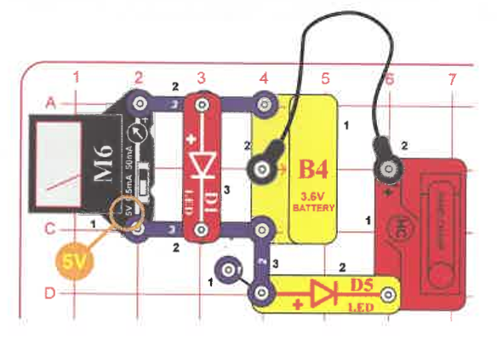
________________
________________
________________

#2: Hand Cranking

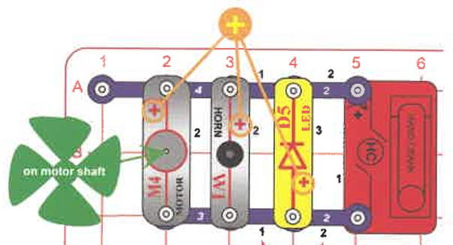
________________
________________

#12: Wind Warning

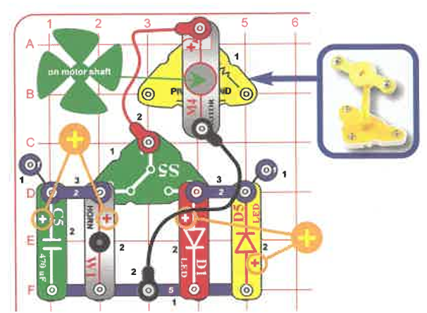
________________
________________

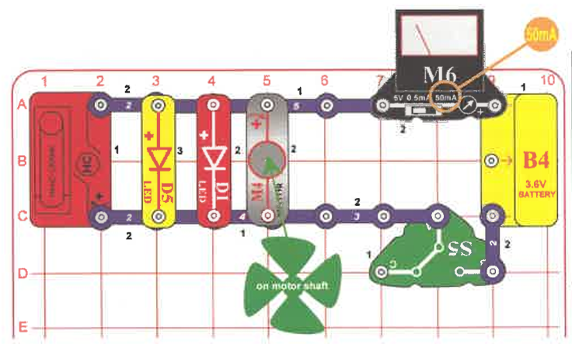
#32: Battery Load Current
________________
________________
________________

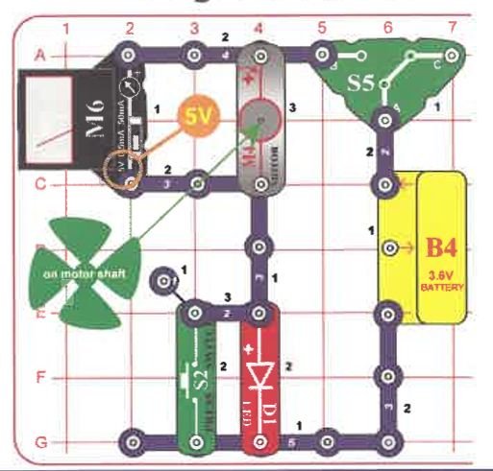
________________
________________
#36: Moving Voltage

Teacher initial for clean-up: __________

Error Analysis:
What about this experiment might others say is not accurate enough? What might make them think your results were not reliable? (2 marks)

Analysis/Conclusion:
- Can energy be transferred from one object to another? Give an example from one of the circuits you have created today. (2 marks)

- Why is it important that each part of the circuit is connected securely to each other in order for the entire circuit to run properly? (1 mark)

- Give two examples of energy transfer in your day to day life. Be sure to indicate what activity/object it is that you are using/doing to describe the energy transformation. (2 marks)

- How can we use the idea of energy transformation in order to generate electrical energy for our everyday use? Discuss your response. (2 marks)

