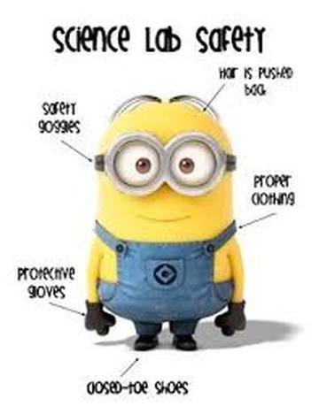 | Science 9  Science Lab Safety |  | Name:  Date:  Block:
- Lab Safety
- WHMIS Symbols

Lab Safety

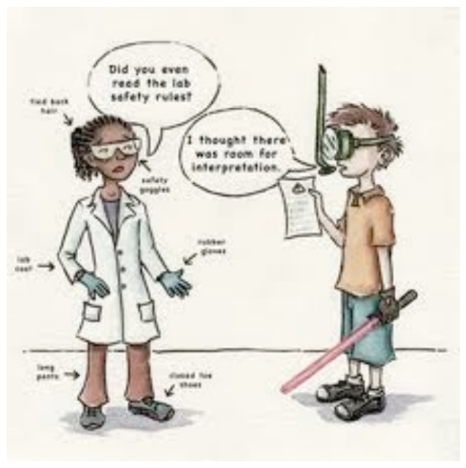
General Precautions:
- Always follow the instructions given to you by the teacher.
- Never perform any experiments without teacher approval.
- Keep the lab clean and uncluttered.
- Make sure all binders, textbooks, and bags are not in the way of your working area and not on the ground.
- Never eat or drink in the lab.
- No horseplay in the lab.
- Make sure you understand all procedures in the experiment; always ask the teacher if you have any questions.
- Read and understand the safety symbols and hazards with the materials you are working with.

Protective Clothing:
- Always wear safety goggles during a lab.
  - Do not take these safety goggles anytime during the lab.
- Wear disposable gloves when working with chemicals or living organisms.
- Wear an apron when working with chemicals.
- Remove any jewelry, ties, or scarves and tie back long sleeves.
- Tie back long hair.
- Tie back loose clothing.
- Wear appropriate footwear any open feet footwear (sandals, flip flops, etc.) are not allowed in the lab.
- Long pants have to be worn in the lab.

First Aid:
- Know where the fire extinguisher, safety shower, fire blanket, fire alarm, and first aid kit is in the laboratory.
- Report any fires, accidents, broken equipment, and/or injuries to the teacher immediately.
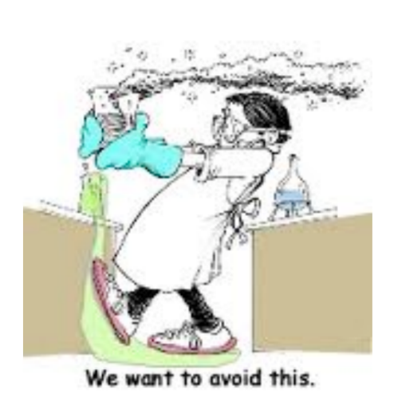
Using equipment:
- Carry only one object at a time. Hold equipment carefully with both hands.
- Make sure you pull the plug on electrical equipment, not the cord.
- Your hands should be dry when working with electrical equipment.
- Do not use equipment that has frayed wires or cords.
- Report all damaged equipment to the teacher as soon as possible.
- Place electrical cords in places where people will not trip on them.
- Place test tubes in a test tube holder to hold them.

Heating and Fire Safety:
- Never heat liquids in a closed container.
- Keep combustible and flammable materials away from the fire.
- When heating test tubes, make sure they are pointed away from yourself and others.
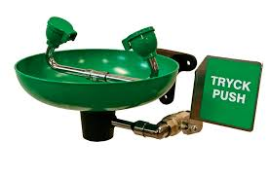
- Use Pyrex or Kimax glass containers when heating.
- Do not place empty containers on a hot plate.
- Use oven mitts when picking up heated containers.
- If clothing catches fire, smother the flame with a fire blanket or a coat; Stop, drop, and roll.

Sharp Materials:
- Always cut materials away from yourself and others.
- Handle sharp materials with care.
- Always cut objects on a flat surface; hold down the object with pins or clamps.

Working with Chemicals:
- Read and understand all safety labels.
- Never taste any substances in the lab.
- If you make contact with a substance, inform the teacher immediately. Immediately wash that area with cold water.
- If chemicals go into your eye, wash them immediately and continuously for minimum 15 minutes. Inform the teacher immediately.
- When smelling a substance, do not smell it directly. Hold the container in front of you and waft the fumes towards your nose.
- Do not mix unknown chemicals together just to see what will happen.
- When diluting an acid, add small amounts of acid to large amounts of water.
- If chemicals are going from one container to another, make sure you label all the containers.
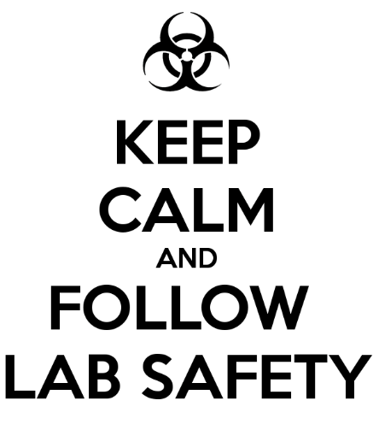
Cleaning up:
- Clean up materials according to teacher’s instructions.
- Do not pour used chemicals back into the original bottles or down the sink. Always follow teacher’s instructions when cleaning up.
- Turn off gas after it has been used.
- Broken glass needs to be placed in a broken glass container. Never use broken glassware.
- Unplug all electrical equipment that was in use.
- Make sure you wipe up any spills made immediately.
- Always wash hands thoroughly with soap after working in a lab.

WHMIS Symbols

The most important consideration we have to take into account when working in the lab, handling chemicals and equipment, and conducting experiments is safety. Safety is key!

WHMIS symbols
WHMIS stands for ‘_______________ _______________ _______________ _______________ _______________’ and they use symbols in order to identify dangerous materials. These symbols can be found on labels of common household items and chemicals.

Symbol | Name | Definition | Example of products that have this symbol
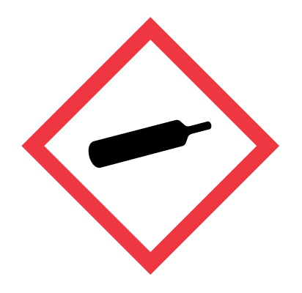 |  | - Gas under pressure  - Heat may cause the container to explode.  - A drop/impact may cause the container to explode.
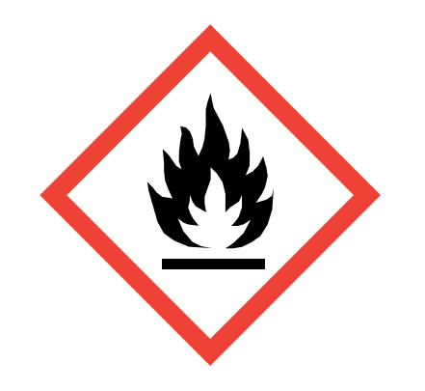 |  | - May burn at low temperatures.  - Sparks, flames, friction may ignite it.
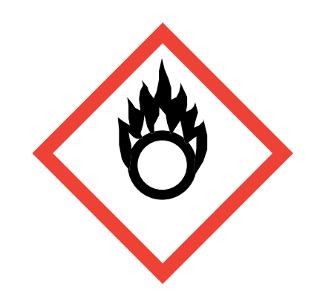 |  | - Speed up development of a fire and make it more intense  - Cause substances that don’t usually burn to readily burn in air
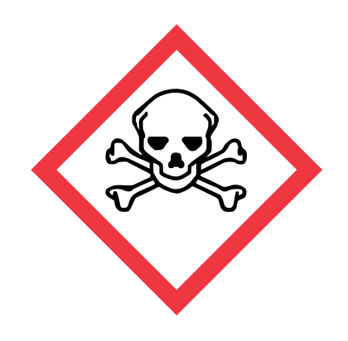 |  | - May cause death/toxicity with short exposure to small amounts.
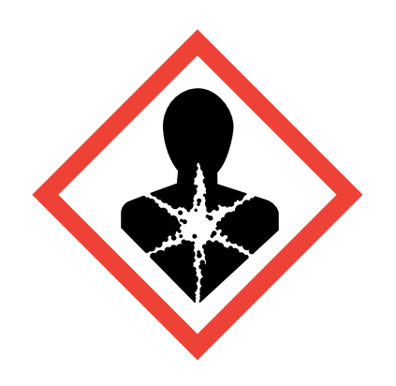 |  | - Suspected to cause serious health effects (cancer, organ damage, genetic defects) after repeated exposure
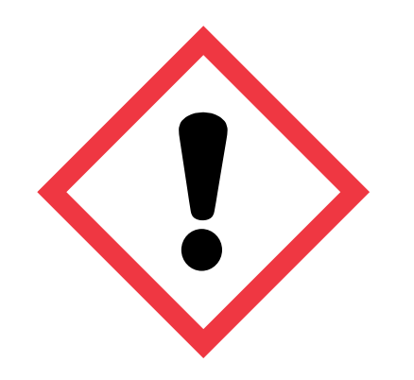 |  | - May cause irritation to skin and eyes.
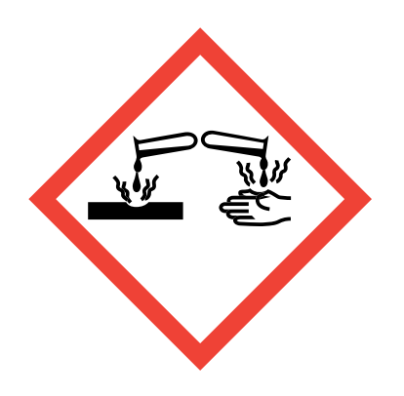 |  | - Corrosive damage to metals, eyes, skin.
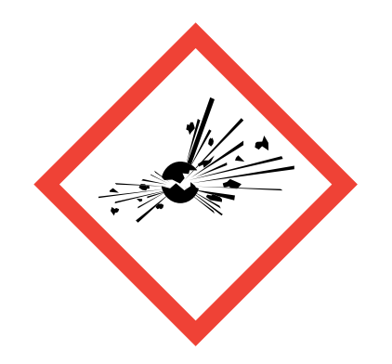 |  | - May be a self-reactive substance  - Explosion may cause damage to surroundings
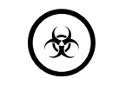 |  | - Organisms/toxins that can cause diseases in people or animals
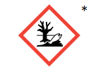 |  | - May cause damage to the aquatic environment (fish, crustacean, or aquatic plants)

Practice!

Fill in the table based on the household products provided

Product Name | WHMIS Symbols on Container | Briefly describe the precautions you should take when using this product

