Science 9  Investigating Simple Circuits |  | Names:  Date:  Block:

Question:
What does a circuit need in order for electrical current to flow? Why?

Hypothesis:
IF we _______________________________________________________________________, THEN ___________________________________________________________________________

Materials:
- dry cell holder | - light bulb
- dry cell | - switch
- 3 conducting wires | - voltmeter
Procedure:

1. Read through this procedure carefully. Gather materials as directed by your teacher.
2. Use the materials to create a circuit where the lightbulb lights up.
3. Draw a circuit diagram of your functioning circuit in your observations - Box 1
4. Use a voltmeter to measure the voltage of your circuit, and record the voltage
5. Combine your materials with those of another team. In Box 2, draw and construct a functioning circuit with your combined materials. Measure and record the voltage.
6. Clean up and return your materials.
7. Complete your analysis and conclusions.

Observations:
In the space below, draw circuit diagrams illustrating the two ways in which you created a functioning circuit. Use appropriate symbols and labels (see Table A).

Voltage (volts)

Box 1 | Battery: ____________  Lightbulb: ____________
Box 2 | Battery 1: ____________  Battery 2: ____________  Lightbulb 1: ____________  Lightbulb 2: ____________

Table A: Circuit Diagram Symbols
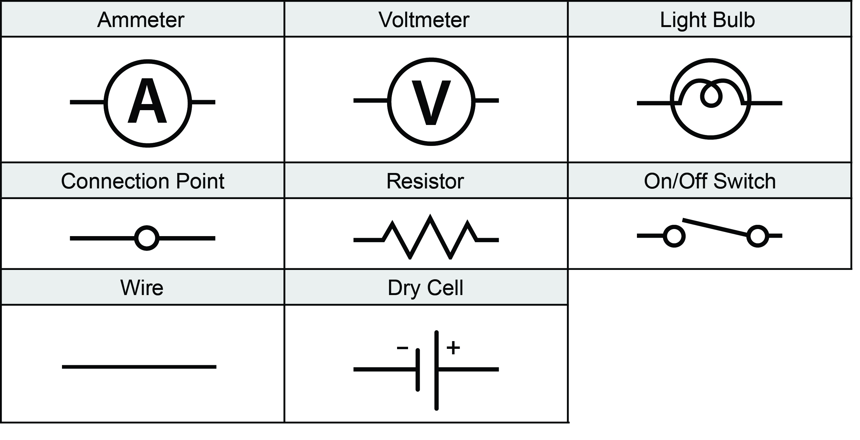
Error Analysis:
What about this experiment might others say is not accurate enough? What might make them think your results were not reliable?

Analysis/Conclusion:

1) What is an electric circuit?

2) Name the three main parts of an electric circuit.

3) What do you notice about your voltage measurements? Why do you think this is so?

4) Give two examples of circuits in your home and explain how they work.

