 | Science 9  Chemistry IV |  | Name:  Date:  Block:

- Ionic Compounds
- Covalent Compounds

Ionic Compounds

Ionic compound: a compound made up of ____________ charged __________ (positive ion + negative ion).
- They are made up of two types of elements: a ____________ and a ___________________.
  - Ionic compounds that contain just two elements are called binary ionic compounds.
- Ions are held together by forming ____________ ____________. These bonds are very ____________.

How do ionic compounds form?
- Atoms of the ____________ element will ____________ one or more ____________ and ____________ the electrons to the _________________ atoms.
- The amount of electrons that elements can gain or lose depends on the element’s _________ ____________.
- Elements will want to gain/lose their electrons in order to achieve _________ ____________ shells. The stability of a full valence shell is what drives the formation of compounds.
For example: Sodium Chloride
- Sodium atoms (the metal) will transfer one electron to the chlorine atoms (the non-metal).
  - Sodium will become ____________ charged (because it is losing one electron): Na⁺
  - Chlorine will become ____________ charged (because it is gaining one electron): Cl⁻
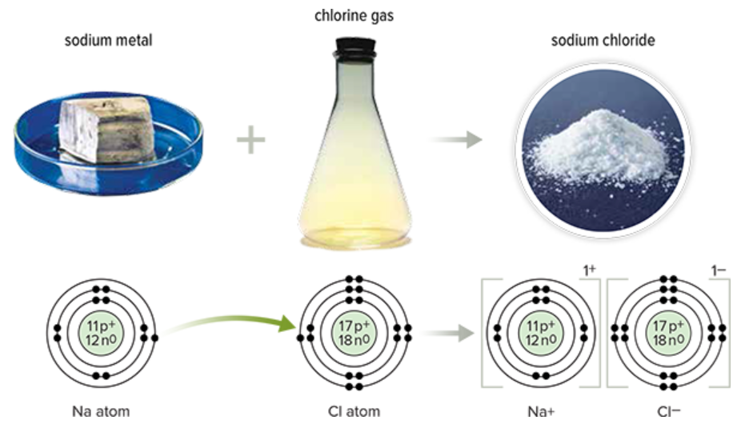
Examples:
Magnesium Fluoride (MgF₂)
Lithium Oxide (Li₂O)

The Structure of Ionic Compounds

Ionic compounds are arranged in ____________.
- A lattice occurs when the positive and negative ions are arranged in regular ____________ patterns.

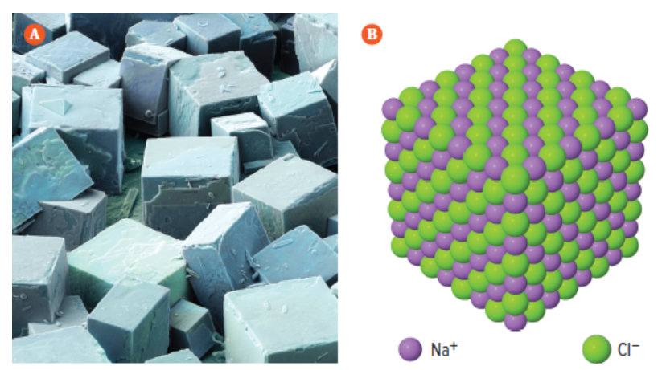

Properties of Ionic Compounds

Common properties of ionic compounds:
- ____________ ____________ ____________
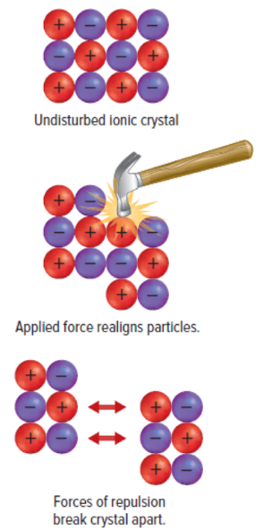
  - In order to melt an ionic compound, the strong ionic bond between the ions have to be broken.
  - As the bonds between the ions are very strong, it takes a lot of energy to break them. This results in ionic compounds needing very high temperatures in order to be melted.
- ____________ and ____________
  - Due to the strength of the ionic bonds, ionic solids are very hard.
  - If enough force is applied, the ions will shift out of alignment from their lattice structure. This causes ions of the same charge to be close together and will result in the ions repelling each other.
- ____________ ____________ of electricity when ____________ or ____________
  - Ionic compounds are NOT good conductors when they are in the solid state.
  - If ionic compounds are dissolved in water, they are good conductors. In this form, the ions in the compound are free to move around and conduct electricity.
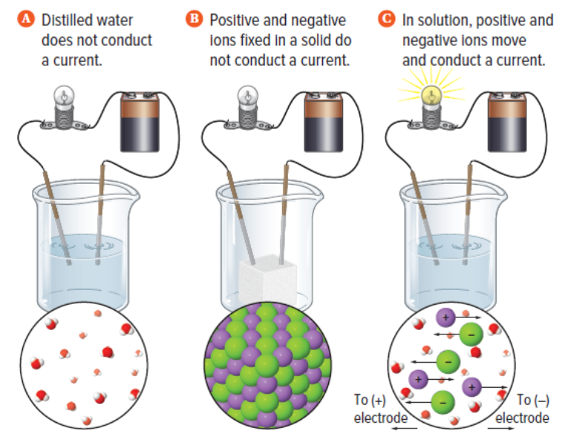

Practice: Drawing Bohr Models of Ionic Compounds

Before Bonding:
Li Cl | Mg O | Mg Cl₂

After Bonding:
LiCl | MgO | MgCl₂

Covalent Compounds

Covalent compounds: a compound that forms when two or more elements ____________ electrons.
- They are made up of ___________________.
- These elements are held together by forming ____________ ____________. These bonds are very ____________.
- Covalent compounds are also known as ____________. A molecule is a particle made up of 2 or more neutral atoms bonded together by covalent bonds.

How do covalent compounds form?
- ____________________ in covalent compounds achieve a full valence shell by ____________ electrons. The stability of a full valence shell is what drives the formation of compounds.
- A covalent bond is a result of a ____________ ____________ of ____________ ____________.
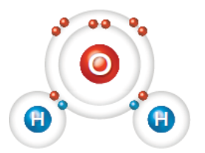
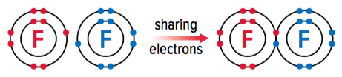

Examples:
Hydrogen gas (H₂)
Methane (CH₄)
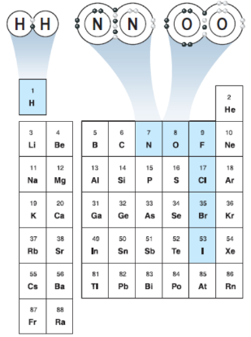
Covalent bonds can also occur between individual elements. These elements are called diatomic molecules.
- Elements that form diatomic molecules: ______, ______, ______, ______, ______, ______, ______.

Properties of Covalent Compounds

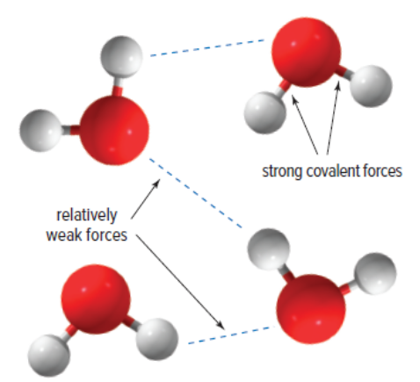
Common properties of covalent compounds:
- Have ____________ ____________ ____________
  - The forces that hold atoms together in molecules are very strong (strong covalent bonds). However, the ____________ that ____________ one ____________ to another are relatively ____________.
  - When melting covalent compounds, you only need to provide enough energy to break the bonds between molecules. As the bonds between molecules are weak, most covalent compounds boil and/or melt at low temperatures.
- Are relatively ____________
  - The forces between molecules are weak. Due to this, it is easier for molecules to shift and move relative to one another.
- Are ____________ ____________
  - Covalent compounds do not have free electrons or ions (they ________________ form ions). Due to this, they are not good conductors of heat and electricity.

Practice: Drawing Bohr Models of Covalent Compounds

Before Bonding:

H₂ O | O F₂

After Bonding:

H₂O | OF₂

