Chemistry 11  Atomic Theory V | Name:  Date:  Block:

- Atomic Radius
- Ionization Energy
- Electronegativity
- Chemical Bonding

Atomic Radius

Periodic Trends
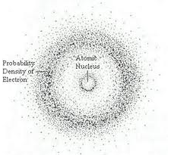
- As we move across a period or down a chemical family, there are regular changes in elemental properties.

The size of an atom
- The volume of an atom is the result of a _______________ of electrons.
- The outer boundary of an atom depends on the size of a cloud in which electrons spend approximately _______ % of their time.
- What affects the size of an atom’s electron cloud?
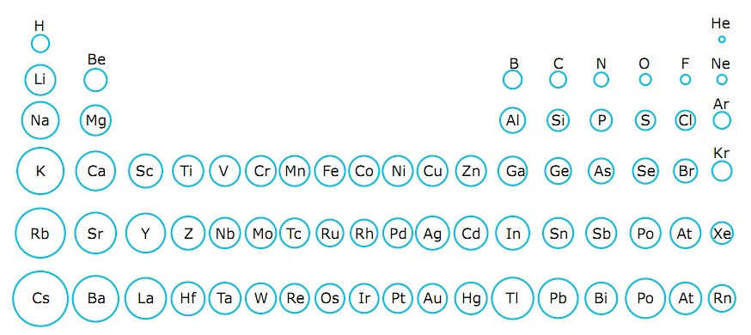

As we move DOWN a family…

- As the number of energy levels (n) increases, _____________________________________________________________________. This makes the atom ________________________.
- Draw the Bohr Diagrams for the following atoms:
Sodium Potassium Rubidium

As we move ACROSS a period…

- As the atomic number increases, the _________________________________________________________________________
- The greater the positive charge on the nucleus, _____________________________________________________________________ ______________________. This _____________________ the size of the radius

Consider this…

Rank the following from largest to smallest by determining:
- How many electrons are in each?
- How many protons are in each?

 | Al³⁺ | F⁻ | Mg²⁺ | N³⁻ | Na⁺ | Ne | O²⁻
# of electrons
# of protons

Ranking: ______________________________________________________________________________________________________________________

Ionization Energy

Ionization Energy: The _____________ required to remove an electron from a neutral atom.

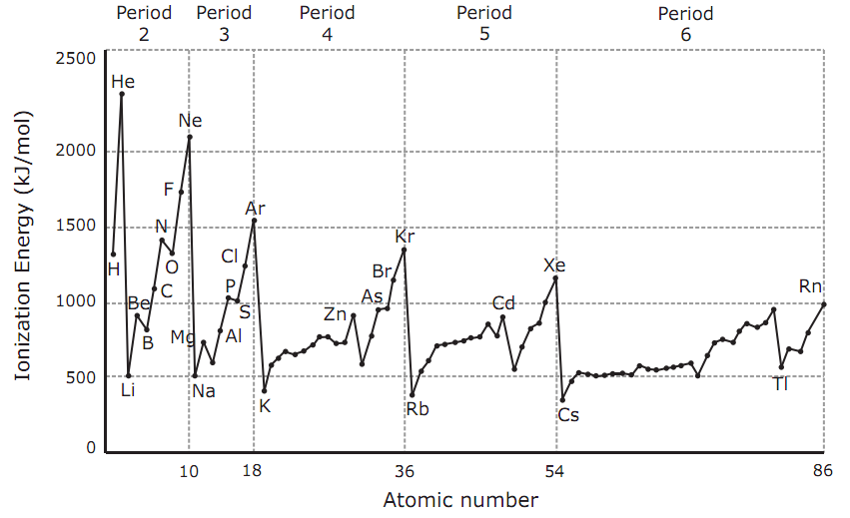

Ionization Energy tells us how strongly an atom holds onto its outermost electrons.
- A large atom has outer electrons that are held ____________ strongly

- A small atom has outer electrons that are held _____________ strongly

This is because of the __________________________________
- Shielding Effect: The weakening of the attraction between the _______________ electrons and ___________ because the electrons in the inner shells are ______________________ the outer electrons

In summary:
- As atomic radius increases…
  - Electrons are held ___________ tightly
  - It takes __________ energy to remove electrons
  - Ionization energy _____________________
- As atomic radius decreases…
  - Electrons are held ___________ tightly
  - It takes __________ energy to remove electrons
  - Ionization energy _____________________

Electronegativity

Electronegativity

Electron affinity is __________________________________________________________________

Electronegativity is ________________________________________________________________

- Smaller atoms are ______________ at attracting electrons because their bonded electrons are so ___________ to their nucleus

- Therefore, smaller atoms have a ____________ electronegativity (EN)
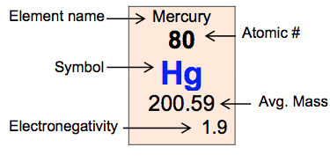

- As atomic radius increases…
  - The nucleus is _________________ from the bonding electrons

  - The atom has a _____________ ability to attract an electron

  - Electronegativity ________________________

- As atomic radius decreases…
  - The nucleus is _________________to the bonding electrons

  - The atom has a _____________ ability to attract an electron

  - Electronegativity ________________________

Summary…
Decreases or increases?

 | Moving LEFT to RIGHT Across A Period | Moving DOWN a Chemical Family
Atomic Size
Reason:
Ionization Energy
Reason:
Electronegativity
Reason:

Chemical Bonding

Atoms Involved | Type of Bond
1. metal bonded to non-metal
2. non-metal bonded to non-metal
3. metal bonded to metal

Ionic Bonding
- Ionic bonding occurs because of the electrostatic attractive force between the oppositely charged ions produced when a metal atom transfers one or more electrons to a non-metal atom.

Important Points:
- Ionic compounds form between ______________ and _________________________ whose electronegativity difference (ΔEN) exceeds ________. They typically form when metals from groups 1 or 2 react with non-metals from groups 16 or 17 of the periodic table.

- During the formation of an ionic bond, metal atoms will ______________ one or more ______________ electrons to the more ___________________________________________ non-metal atoms.
This occurs because the metal’s relatively low ________________________________ and ________________________________.

- Ionic compounds form structures known as ____________________________.
The vast number of attractive forces present in such lattices account for the high melting temperatures of ionic compounds.

Practice 1:
Write formulas for the ionic compounds form when the following elements combine:

a) Ba and Br | b) Be and O | c) Sr and N | d) Mg and Cl | e) Fr and F

Practice 2:
Write formulas for the compounds formed when the following elements combine and justify that the bonds present are ionic by determining the ΔEN in each case.

a) Ca and Br | b) Al and O | c) Be and O | d) Rb and N | e) Ba and Cl

Covalent Bonding

- A bond formed from the sharing of electron pairs between atoms
- Can be ____________________________ or __________________________________

- Important Points:

- Covalent compounds form between two ______________________.

- Because no electron transfer occurs and no ions form, all of the species prior to and following covalent bond formation between two atoms are electrically neutral.

- The force of attraction in a covalent bond is between a pair of _______________ and two adjacent positive _________________, rather than between a cation and an anion.
Electrons in covalent bonds are always associated in pairs.

- Covalent compounds exist as independent molecules rather than large crystal structures.

ΔEN | Bond Designation

Practice 1:
Justify that the bonds present are covalent by determining the ΔEN in each case.

a) N and F | b) C and H | c) Si and N | d) C and S | e) O and O

Practice 2:
Calculate the ΔEN values for the bonds in the following compounds. Then arrange the compounds in order from those containing bonds in which the electrons are shared most equally to those in which the electrons are shared most unequally.

a) H₂O | b) PCl₃ | c) Cl₄ | d) SiO₂ | e) AlN

Practice 3:
Complete the following table:
Elements Present | Formula | ΔEN values | Nature of Bonds | Atom Possessing Greater Electron Density
C and S
B and Cl
Al and O
N and I
Ca and F

Does every metal & non-metal combination result in an ionic bond? Explain.

